Integrate AWS with Lambda and API Gateway and Monitoring

Architecture :

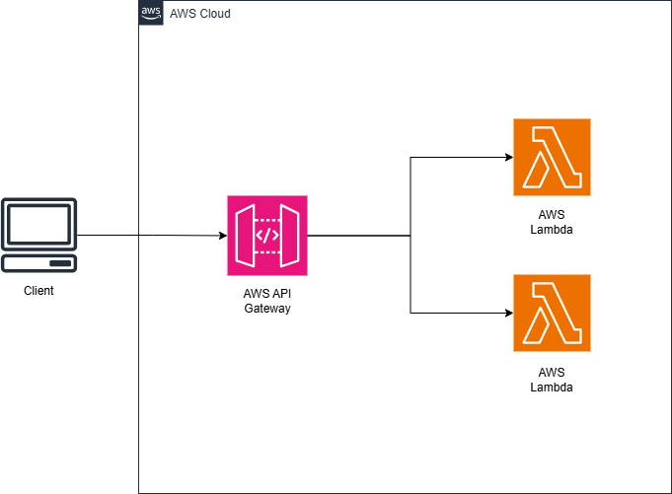

Service used :

* AWS Lambda
* AWS API Gateway

Walkthrough:

**PART 1 : Creating the Lambda and monitor the function logs**

1. Open up the AWS Console and open the Lambda services, choose to create a new Function.

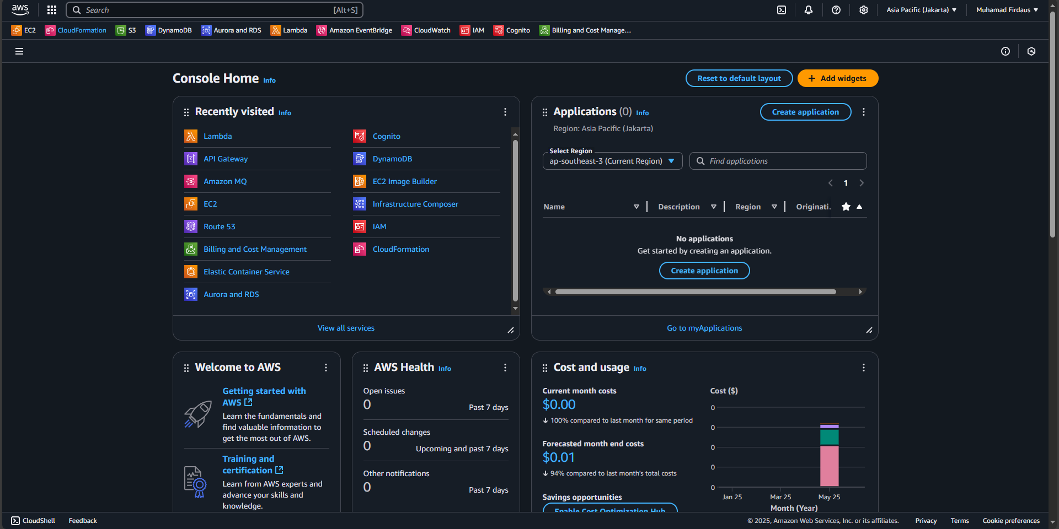

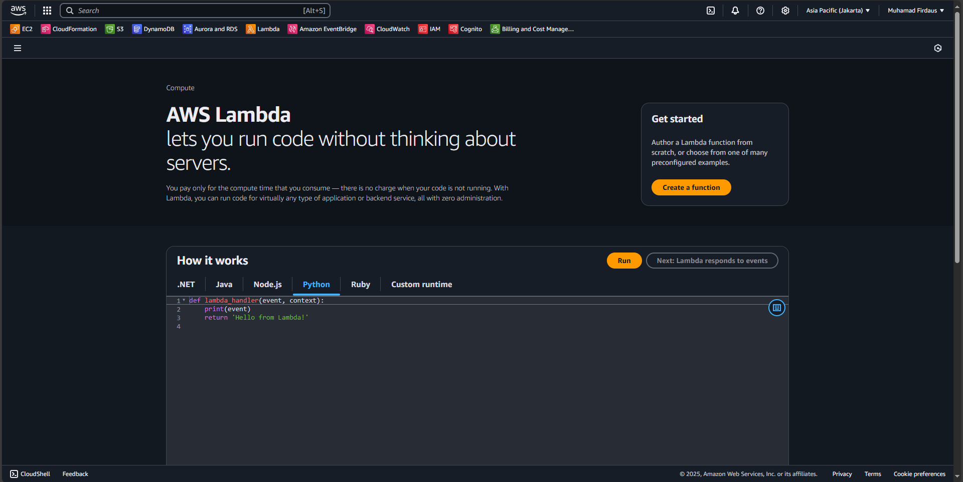

1. Fill the function details with information that you want, in this case I am using below options to fill the details and after that choose to create the function :

|  |
| --- |
| Option : Author from scratch  Function name : dausFunction1  Runtime : Python  Architecture : x64 |

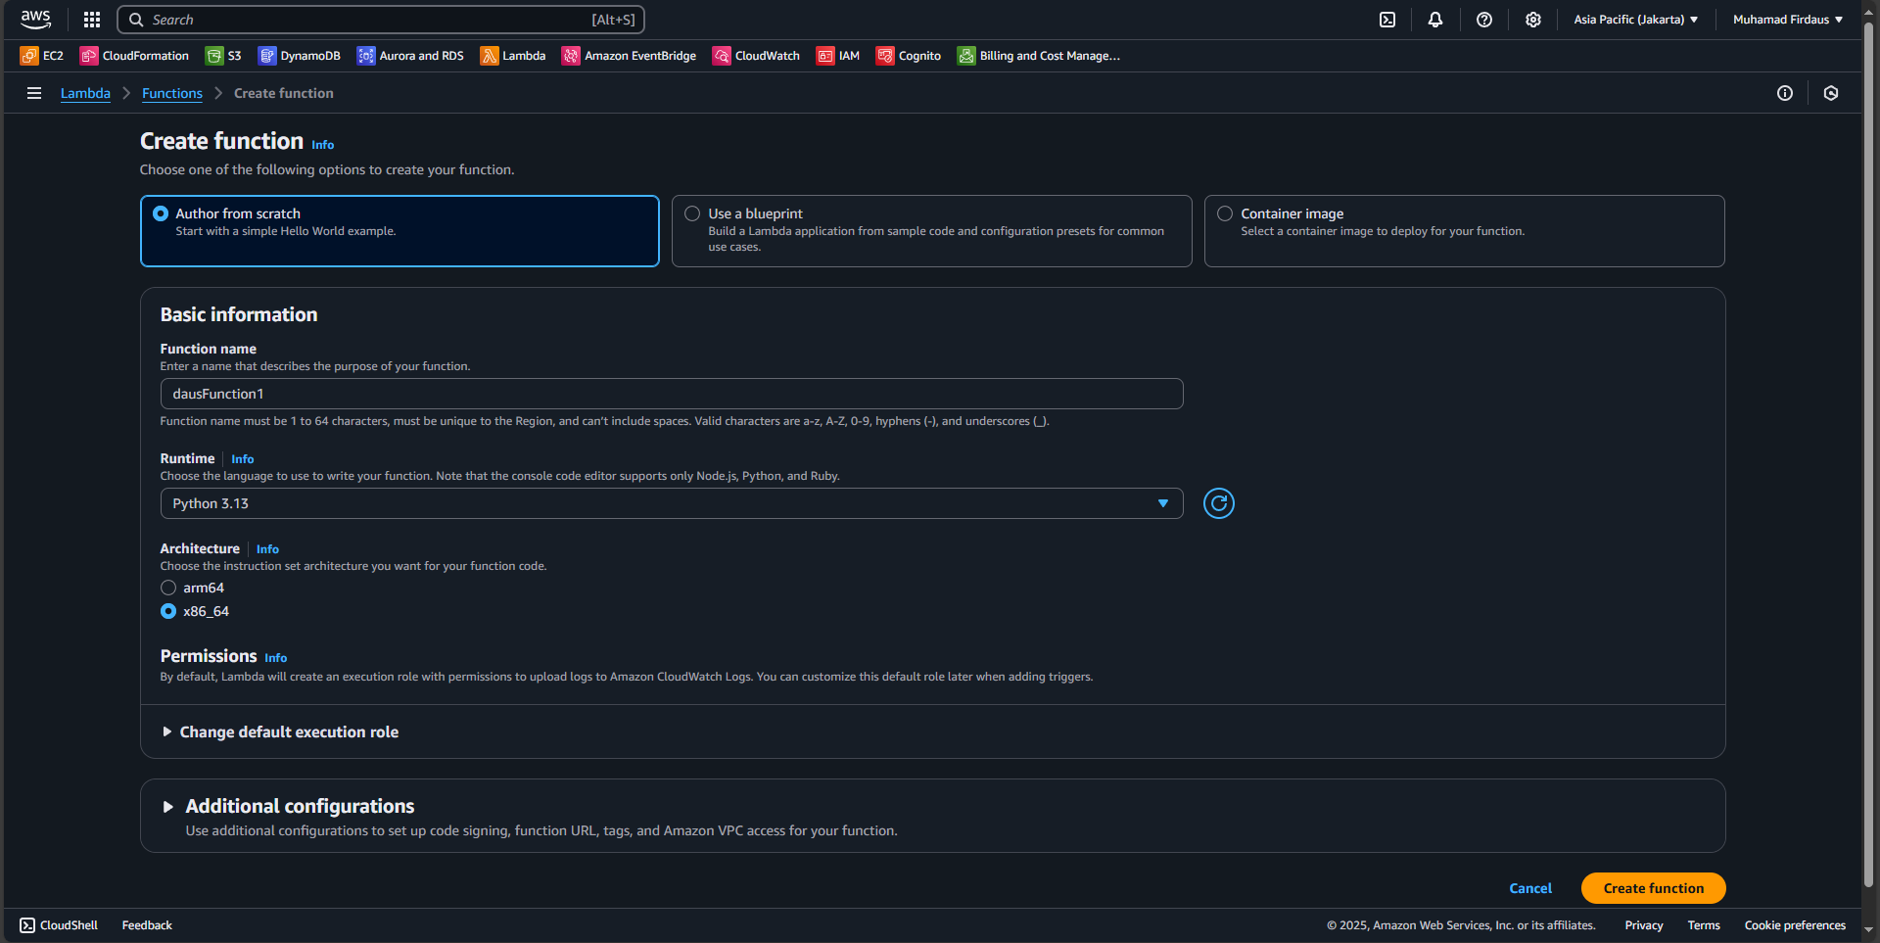

1. A pop up will show after the service created the new function, after the pop up choose the “Test” button on the bottom screen to open the section.

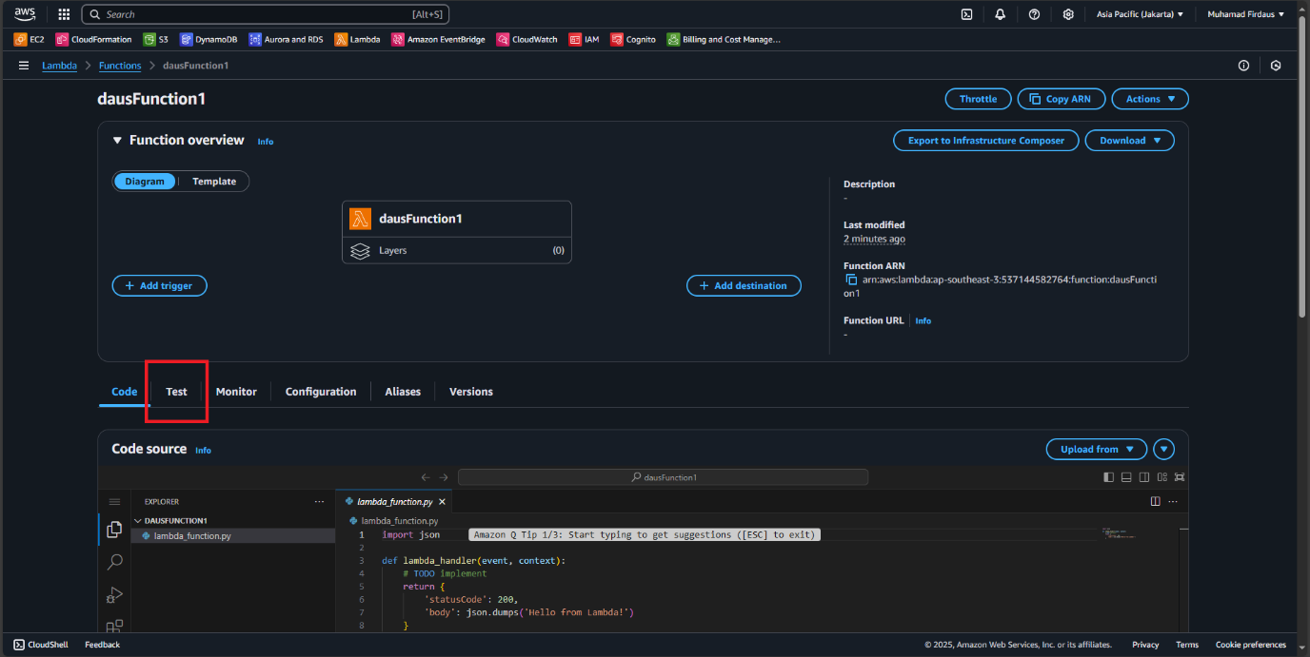

1. On the “Test” section, edit the details with the following details so we can use it to test the function and after that click on the orange “Test” button on the right above screen.

|  |
| --- |
| Test event action : Create new event  Event name : TestEvent  Event sharing settings : Private  Template : Hello World |

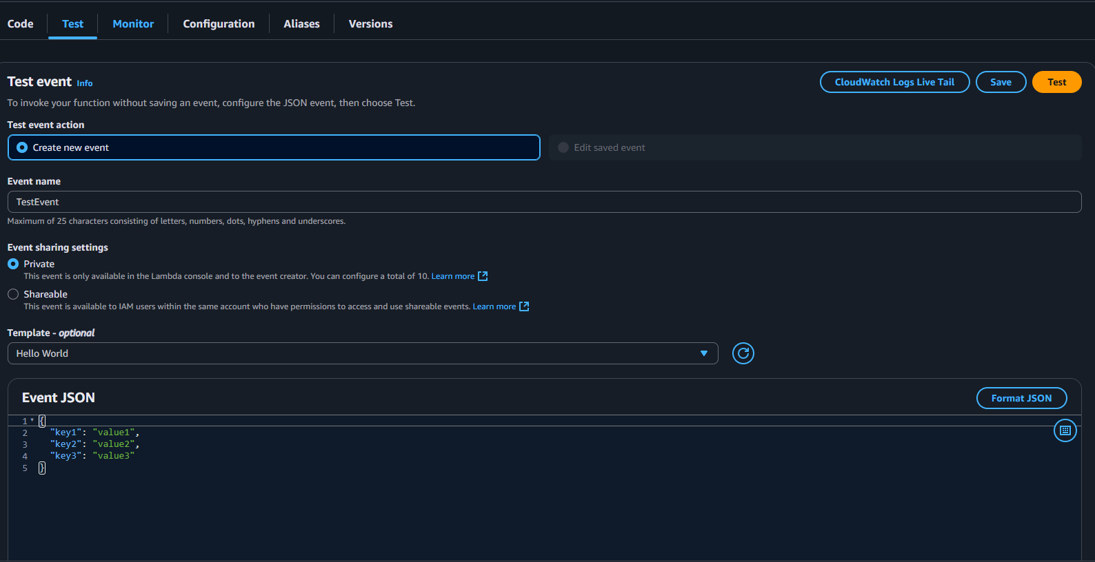

1. The result of the function test will then pop up to give us the details regarding the function testing.

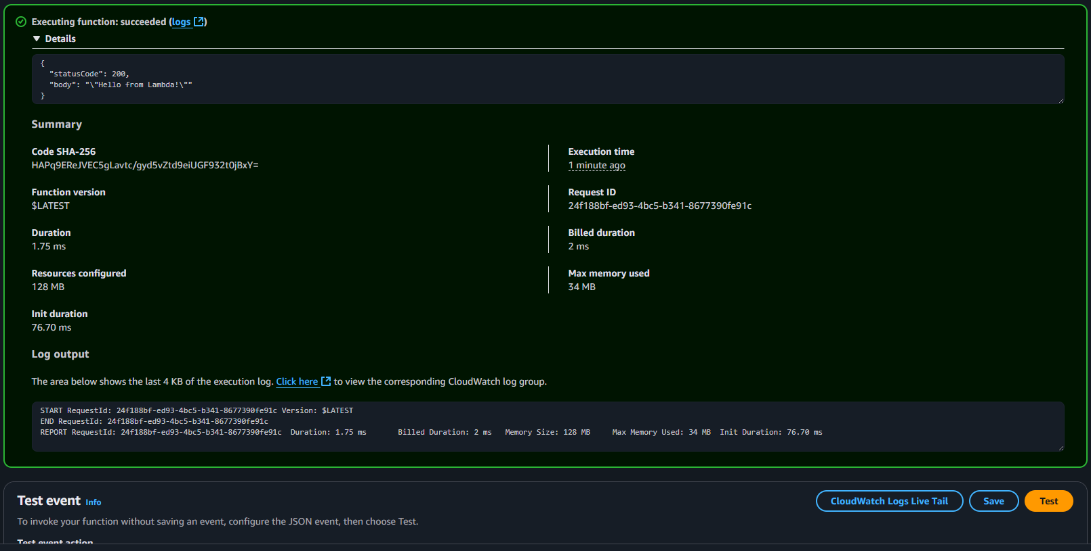

1. Now we can see the CloudWatch logs regarding the function testing on the CloudWatch section, click on “Monitoring” and choose “View CloudWatch Logs”. On the monitoring tab you can also see a dot that list our testing history activity.

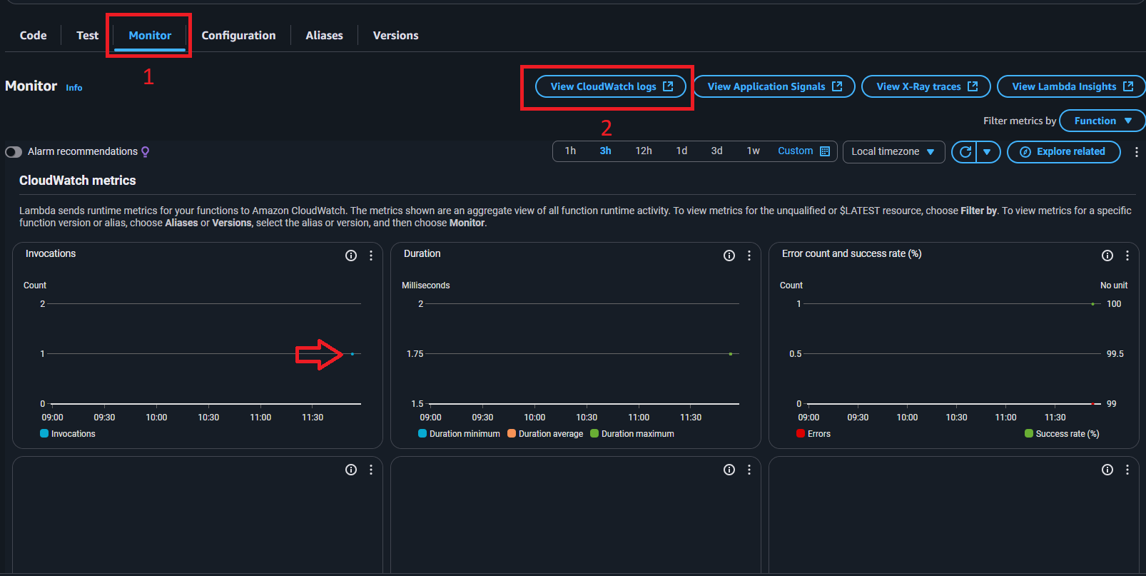

1. On the CloudWatch pop up, choose the newest log name on the log stream (the blue one) and click it to get redirected to the logs menu.

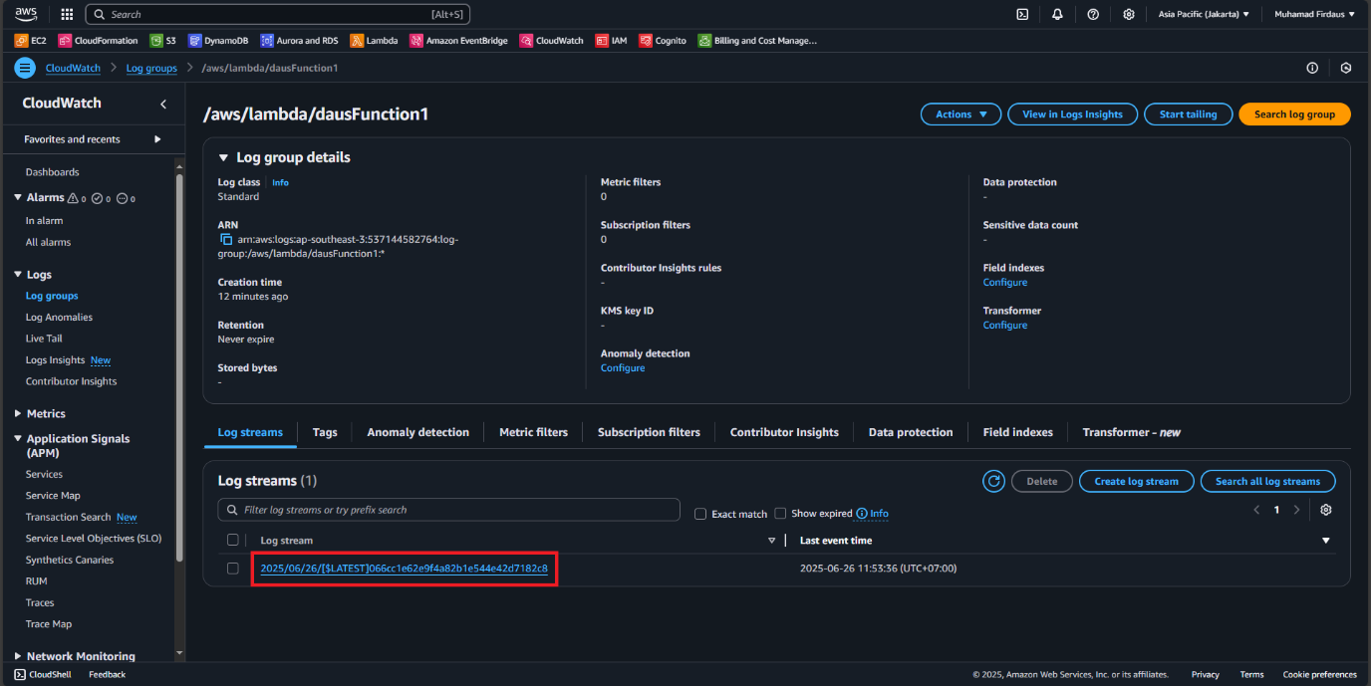

1. The log event then will show the detail regarding the running function process that we can see.

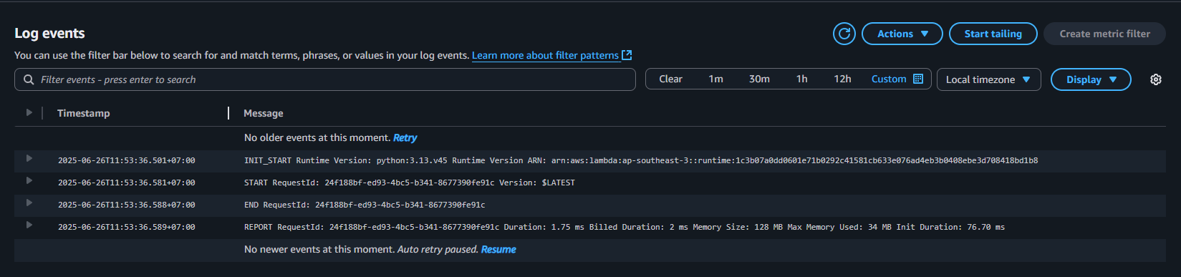

**PART 2 : Connecting Lambda function with the API Gateway**

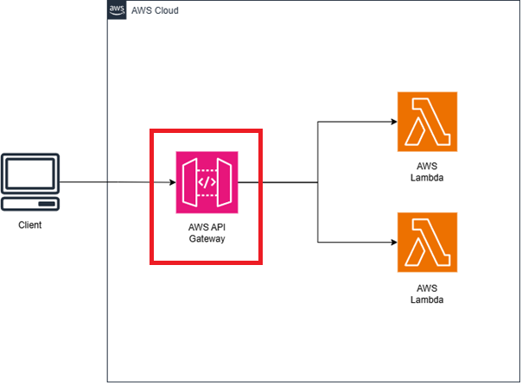

1. On the AWS Console, search for API Gateway service and enter the service. We will create the API Gateway (I will mention it further as APIGW) to connect to the lambda function. Choose to create a new API.

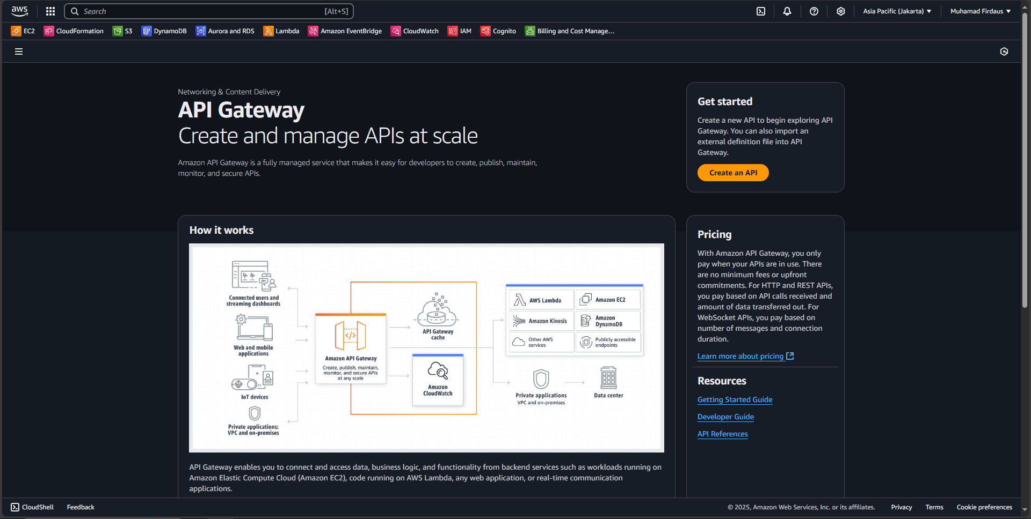

1. On the creation page, you will be asked with what kind of API you want to create. We will continue by using REST API (not the private one).

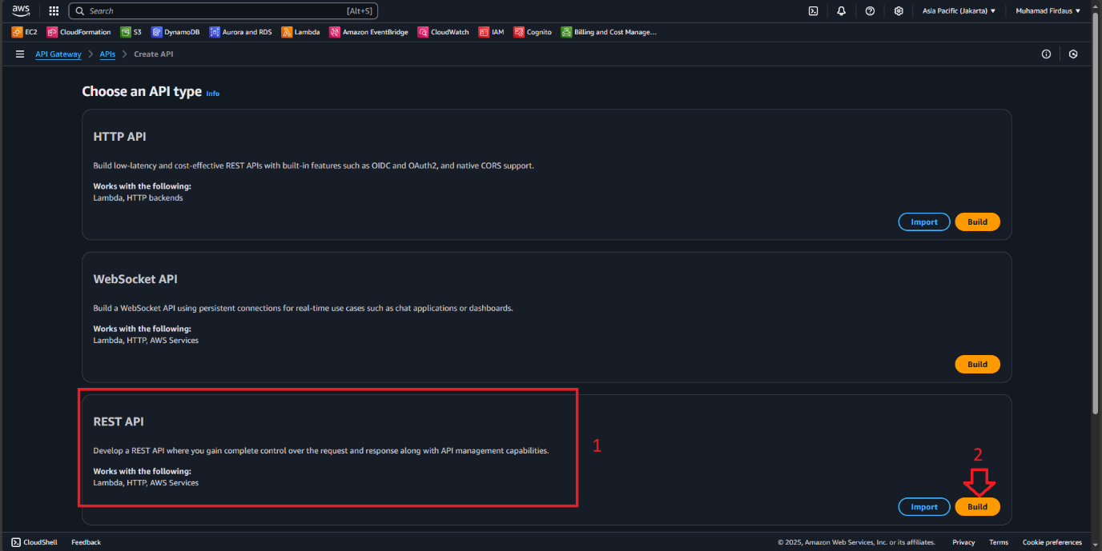

1. On the API creation page, choose to fill the details as you see fit. In this case I will be using below details to continue and choose to create the API :

|  |
| --- |
| API Details : New API  API name : Serverless Test  Description : Testing Serverless Service  API endpoint type : Regional  IP address type : IPv4 |

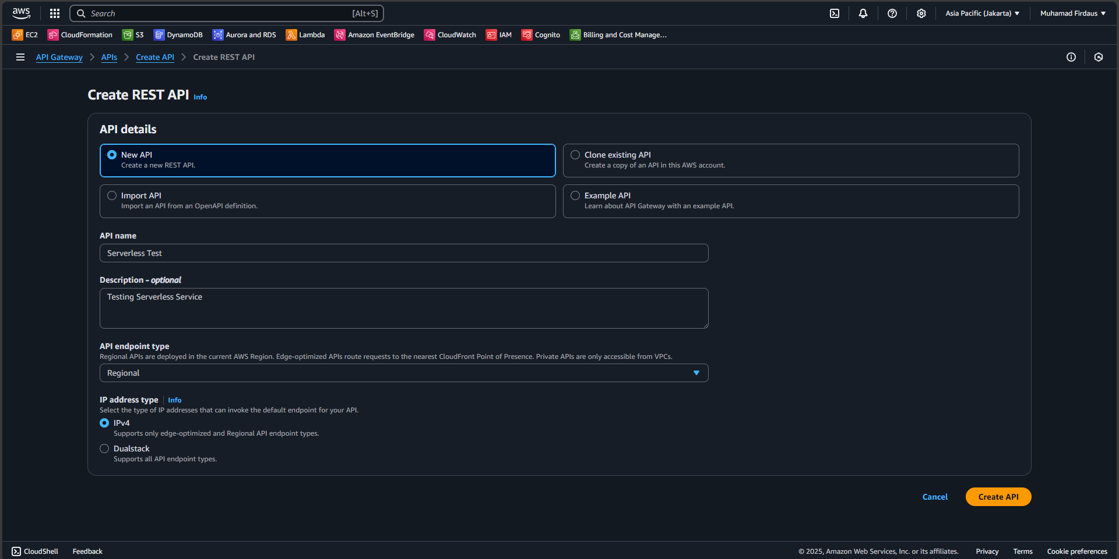

1. A page will then popup showing you the finished process of creating the new API, now on that popup page we will choose the “Create Resource” option to create a new resources.

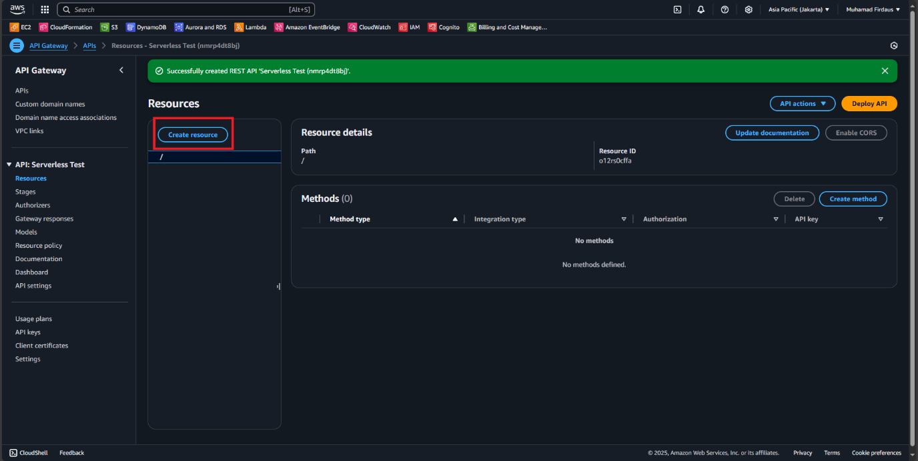

1. On the create resource section, fill in the details with default setting while adding the name of the resource as “helloworld”.

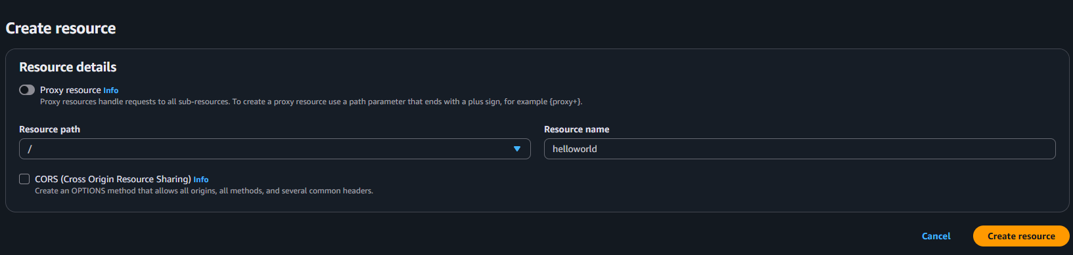

1. After creating the resource, a new pop up will show us that the resource is successfully created. And then we choose the “create method” option AFTER we click on the /helloworld to create a new method for our resource under the /helloworld resource.

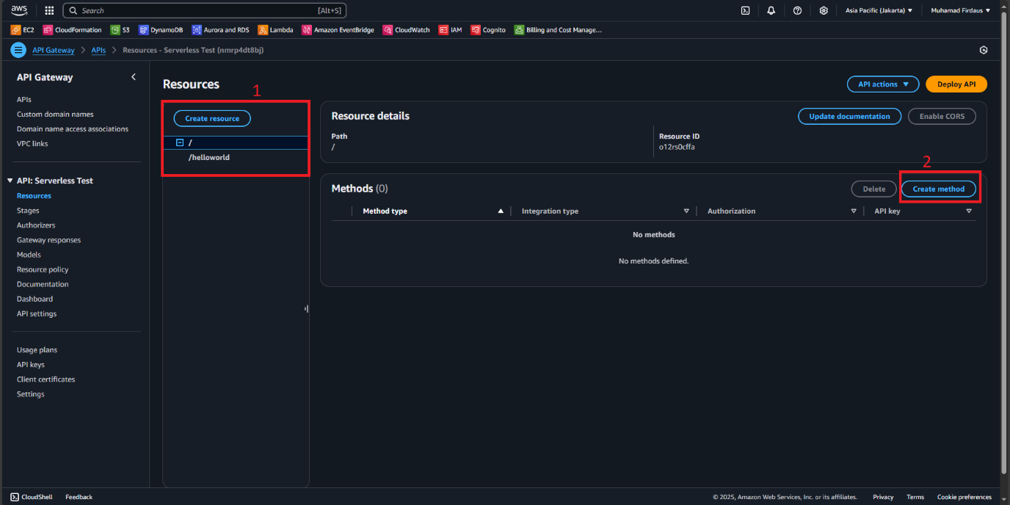

1. On the create method page, we fill the details with the below information to proceed with our method creation and then choose create method.

|  |
| --- |
| Method type : GET  Integration type : Lambda function  Lambda proxy integration : off  Lambda fucntion : our created function earlier in my case it is dausFunction1  Integration timeout : left it default |

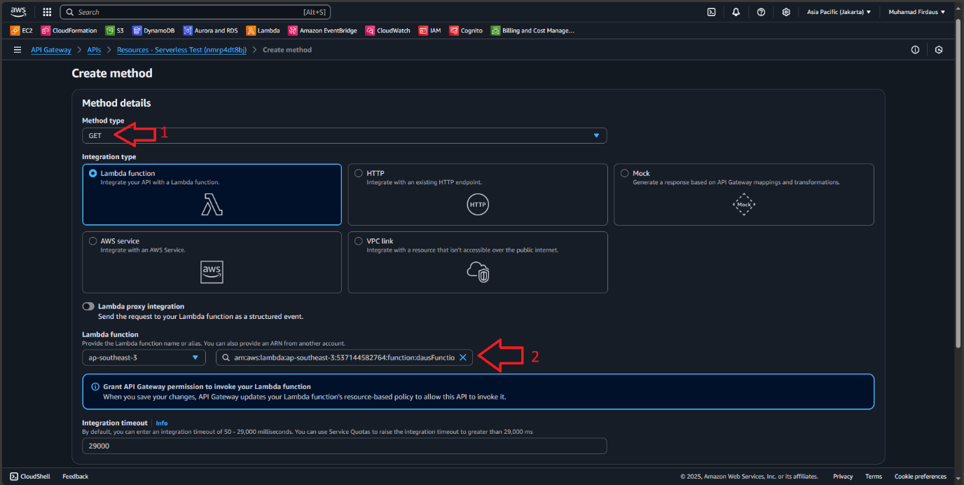

1. After the method was created, the GET method will appear under the /helloworld on the resource tab, confirm this to proceed. Then click on the “Deploy API” so we can begin to prepare to deploy our API

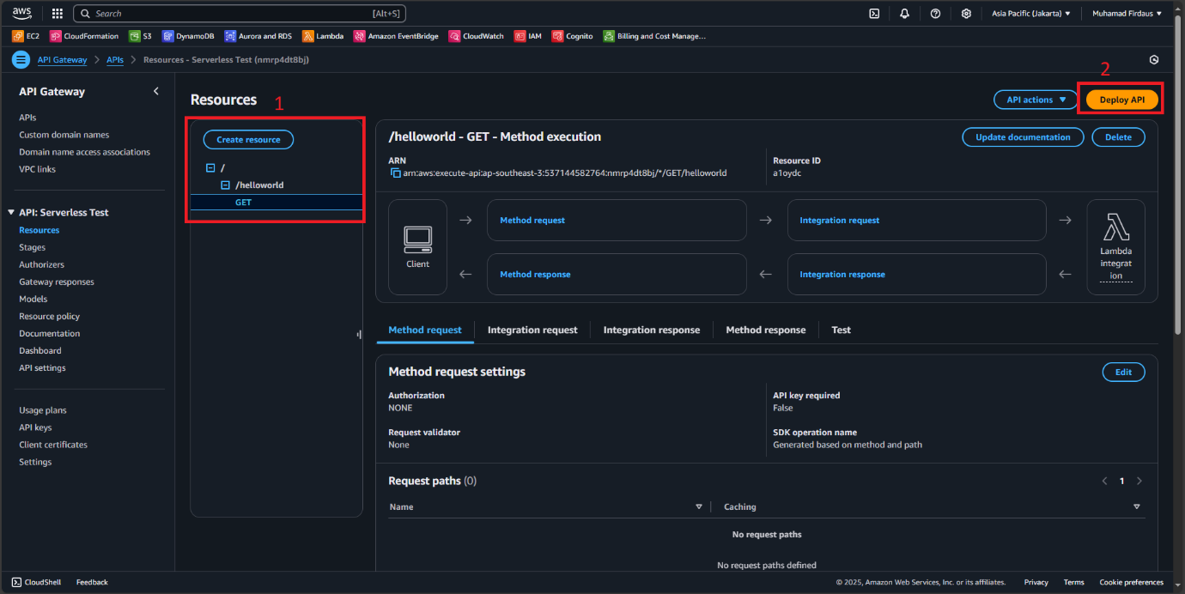

1. A popup will appear for us to configure the API deployment, use below option to fill the required field and then “Deploy”.

|  |
| --- |
| 1. Stage : *New stage* (Its a dropdown menu) 2. Stage name : PROD 3. Description : PRODv1 |

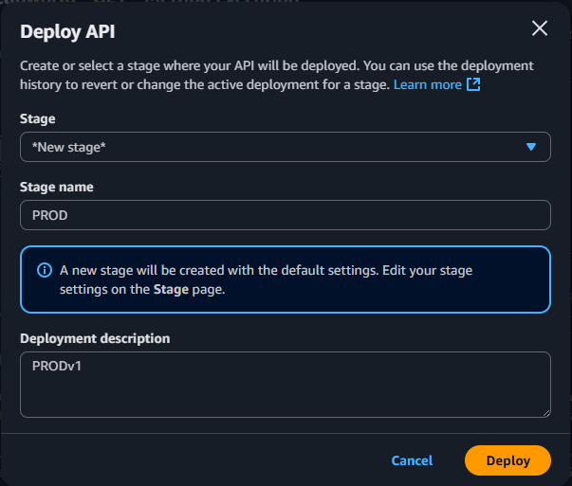

1. After we clicked the deploy button, a new page pop up showing us the stages of the method, open all the stages until you get to the GET stages, click on it to reveal the method content and then copy the “Invoke URL” for us to be able to use it on API testing tools.

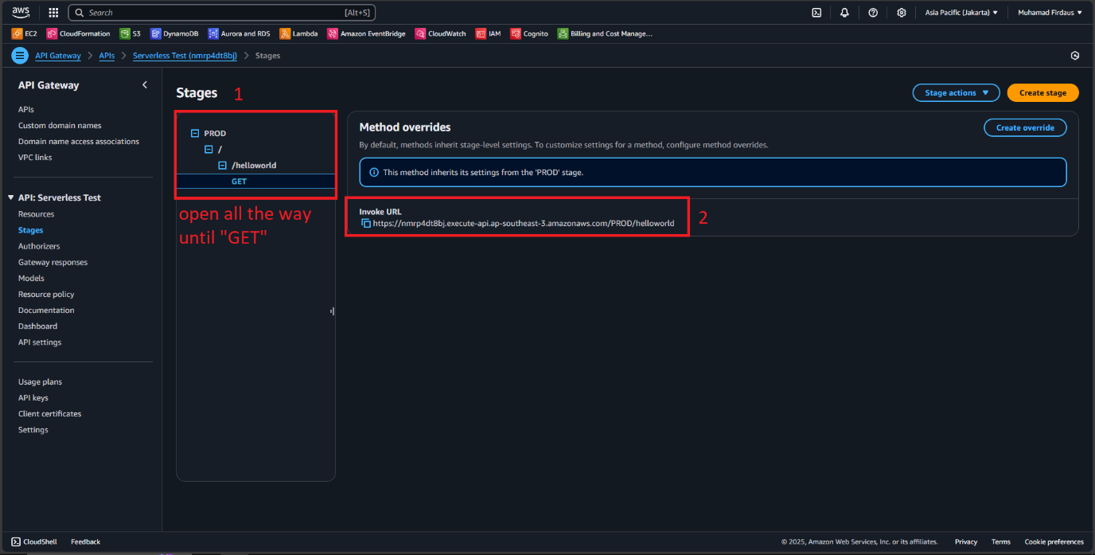

1. Open up your API testing tools such as Postman API or Insomnia, then click on a new testing environment, use the GET method and then paste the Invoke URL we previously copied on the AWS API Gateway and then click on send request.

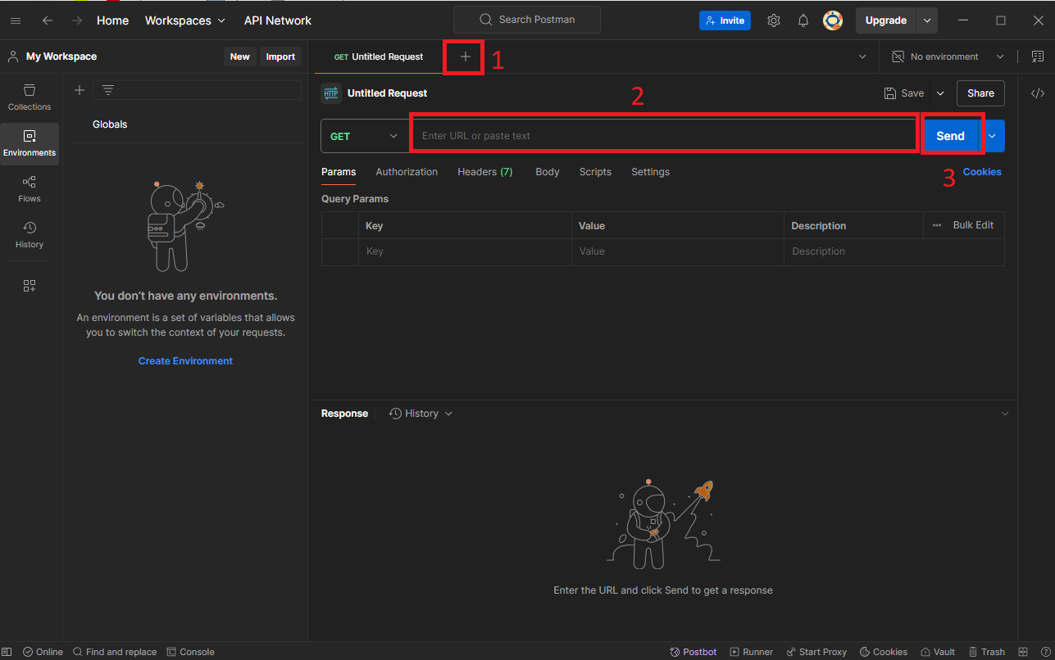

1. If the configuration is correct, we will get the response from the AWS API Gateway with status 200 OK and the Hello from lambda message.

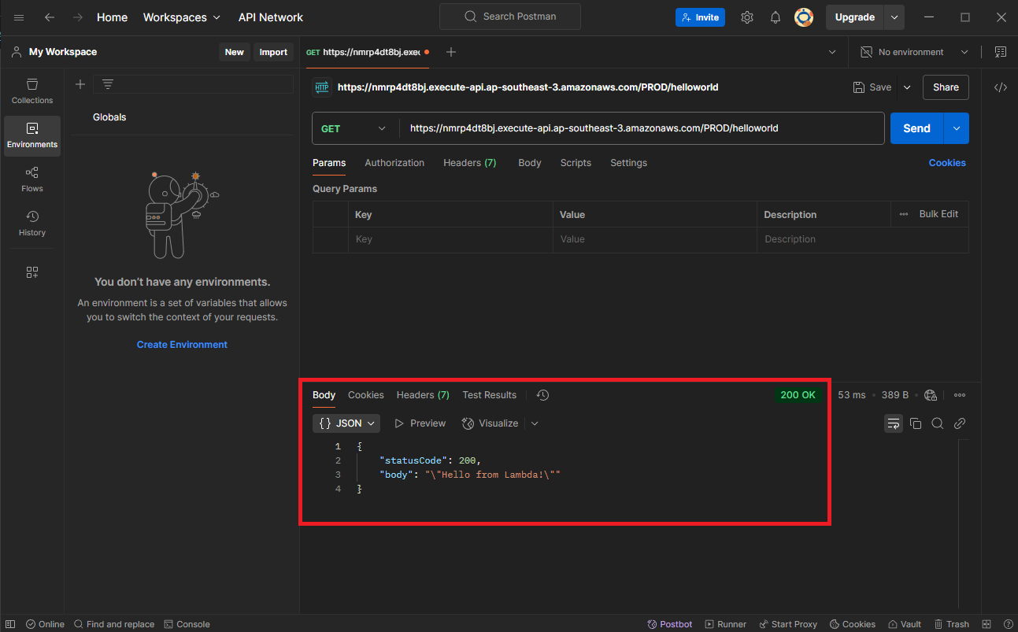

**PART 3 : Implement API Canary on the API Gateway**

1. Open up the lambda service menu, we will create a new function this time.

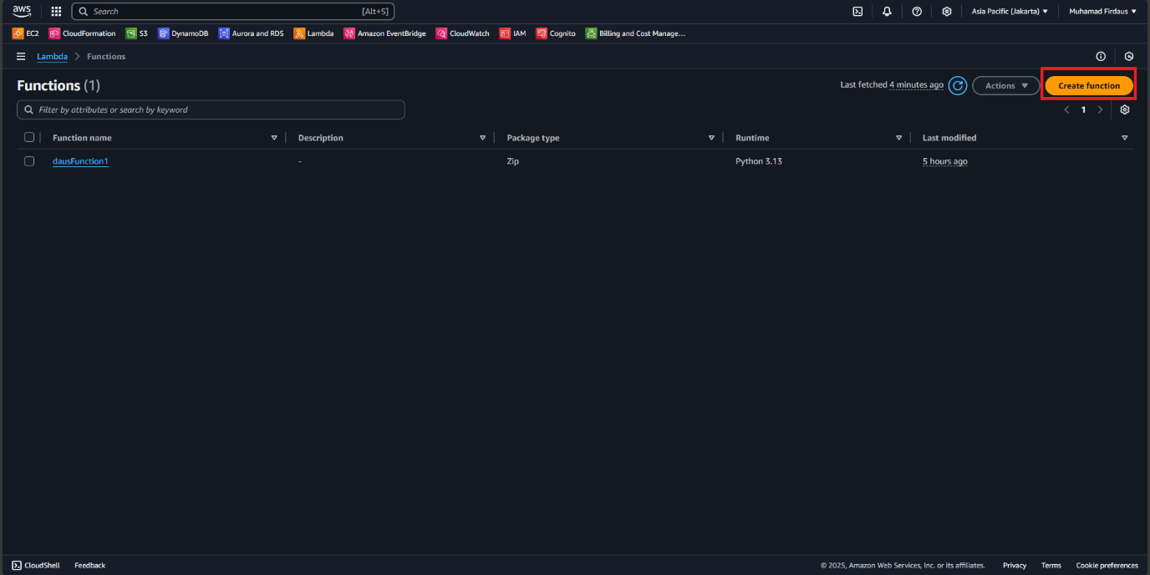

1. Fill out the required information for our second function, I use the specification below for my second function.

|  |
| --- |
| Create function : Author from scratch  Function name : dausFunction2  Runtime : Python  Architecture : x64 |

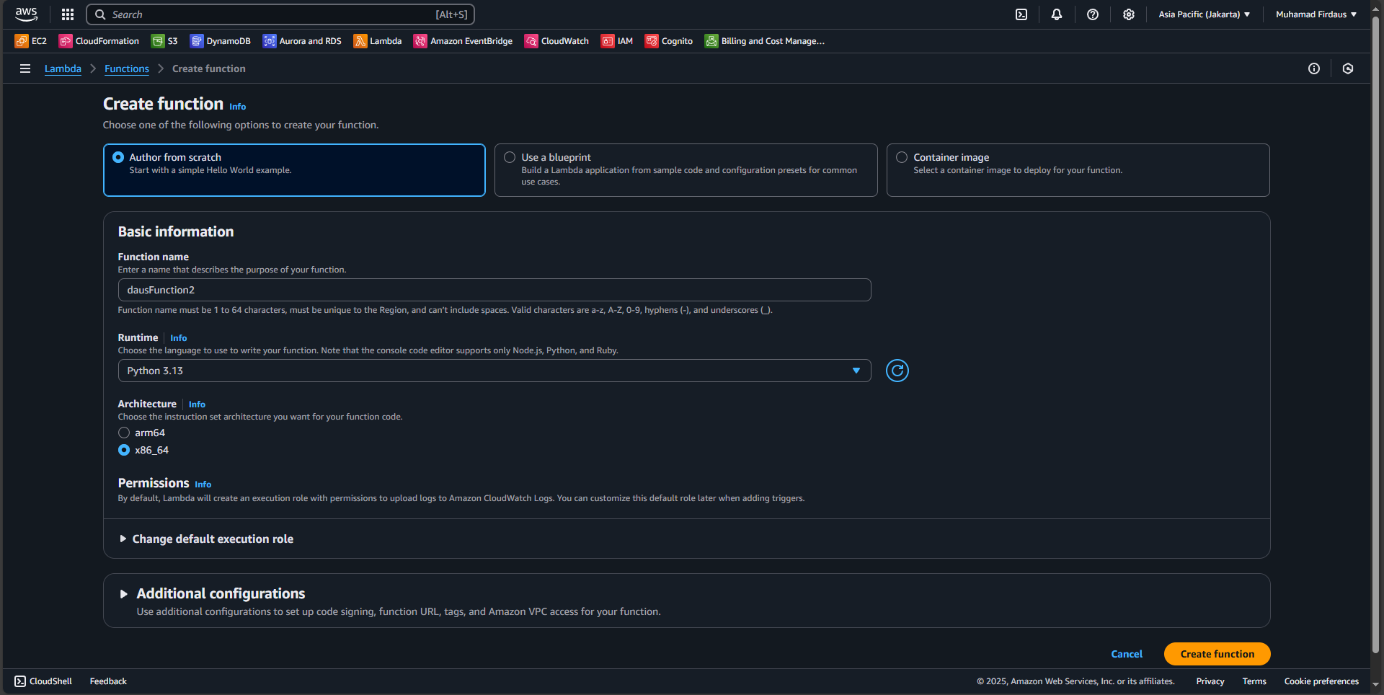

1. On the code source, we change the successful message a little bit. You can edit it however you want and DON’T FORGET TO DEPLOY THE CHANGES FIRST before proceeding.

|  |
| --- |
| import json  def lambda_handler(event, context):  # TODO implement  return {  'statusCode': 200,  'body': json.dumps('Greetings from Firdaus!')  } |

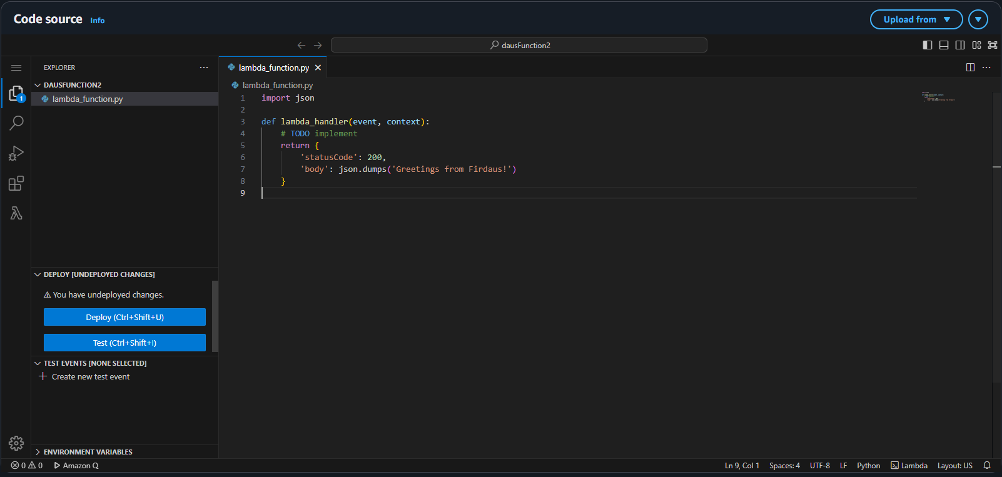

1. On the stages section, click on the “PROD” option, and choose “canary” menu on the right bottom of the page.

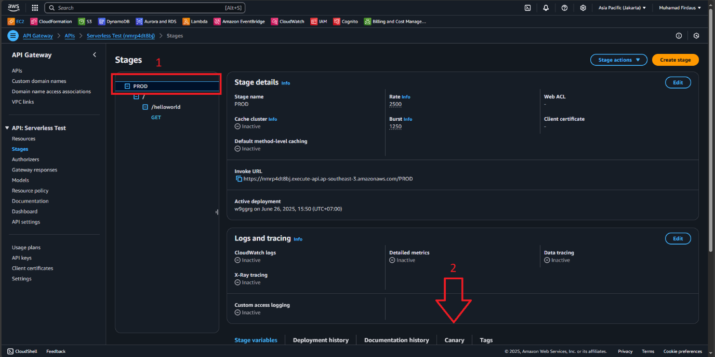

1. Choose to create a new canary by clicking on “create canary” button.

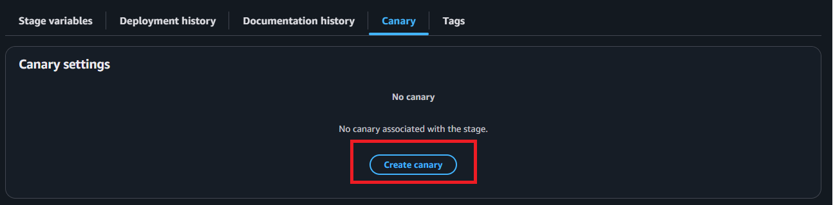

1. On the create canary menu, I will be splitting the canary and the current stages with equal percentages of 50%, this will split the traffic in equal way towards both stages.

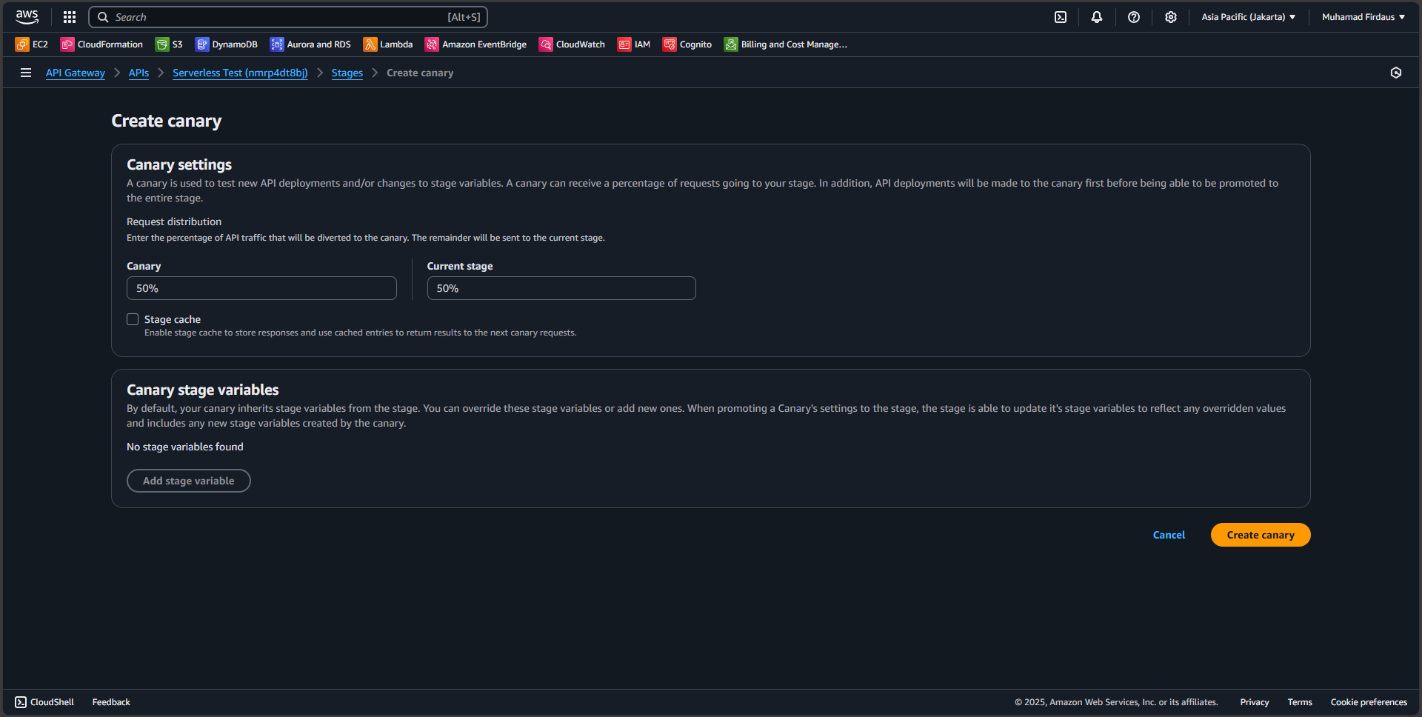

1. Back to the stages menu, check if your new canary is already created, and then click on the resource tab as we will create a new resource for the canary stages.

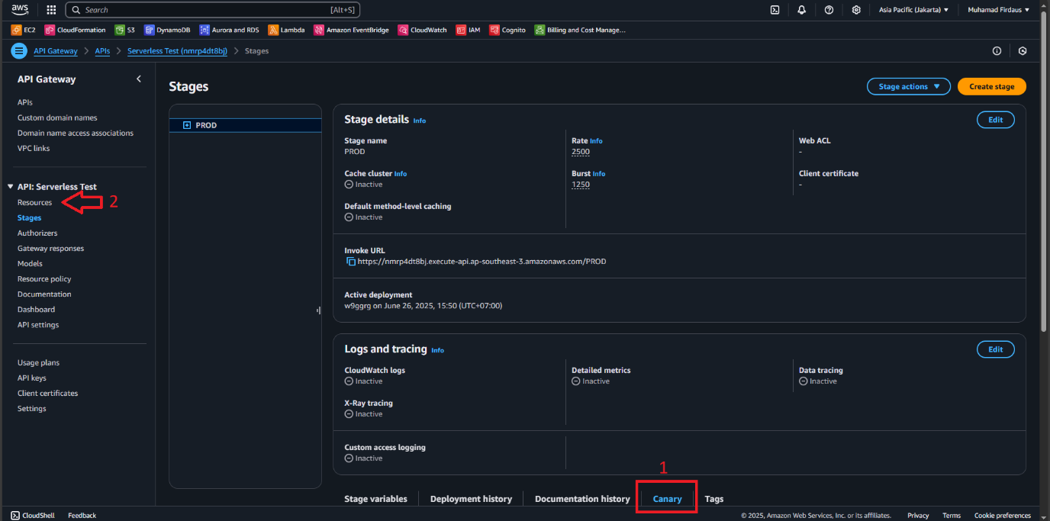

1. Click on the “Create resource” button to open up the creation menu.

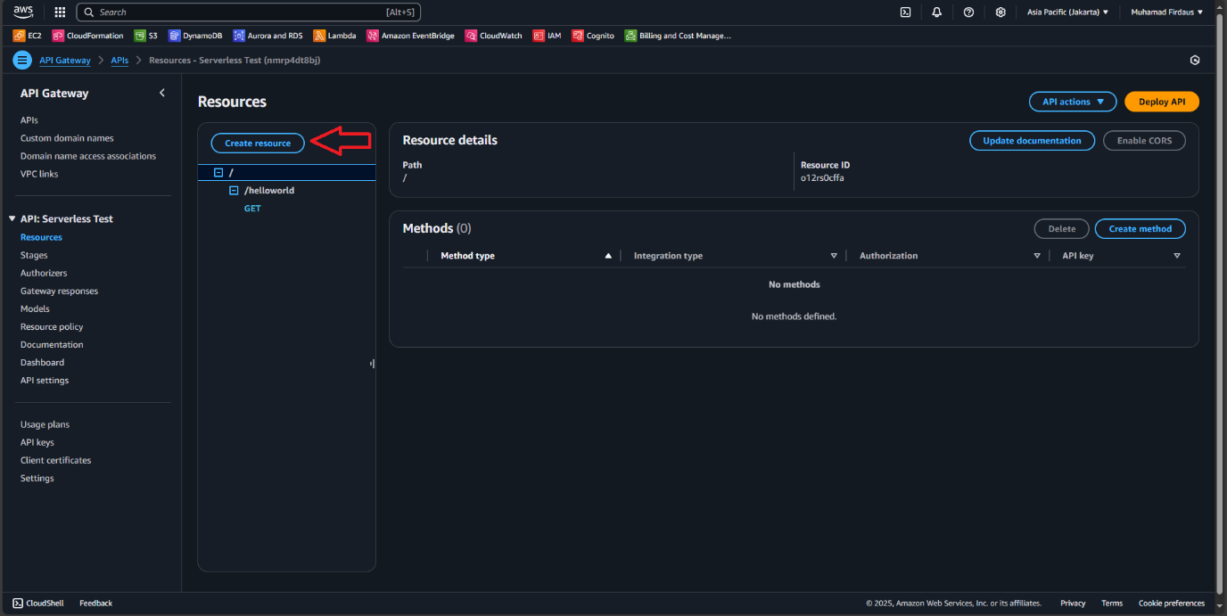

1. On the resource detail page, enter “v2” or any other resource name you want to name it, still within the “/” path, then choose to create this resource.

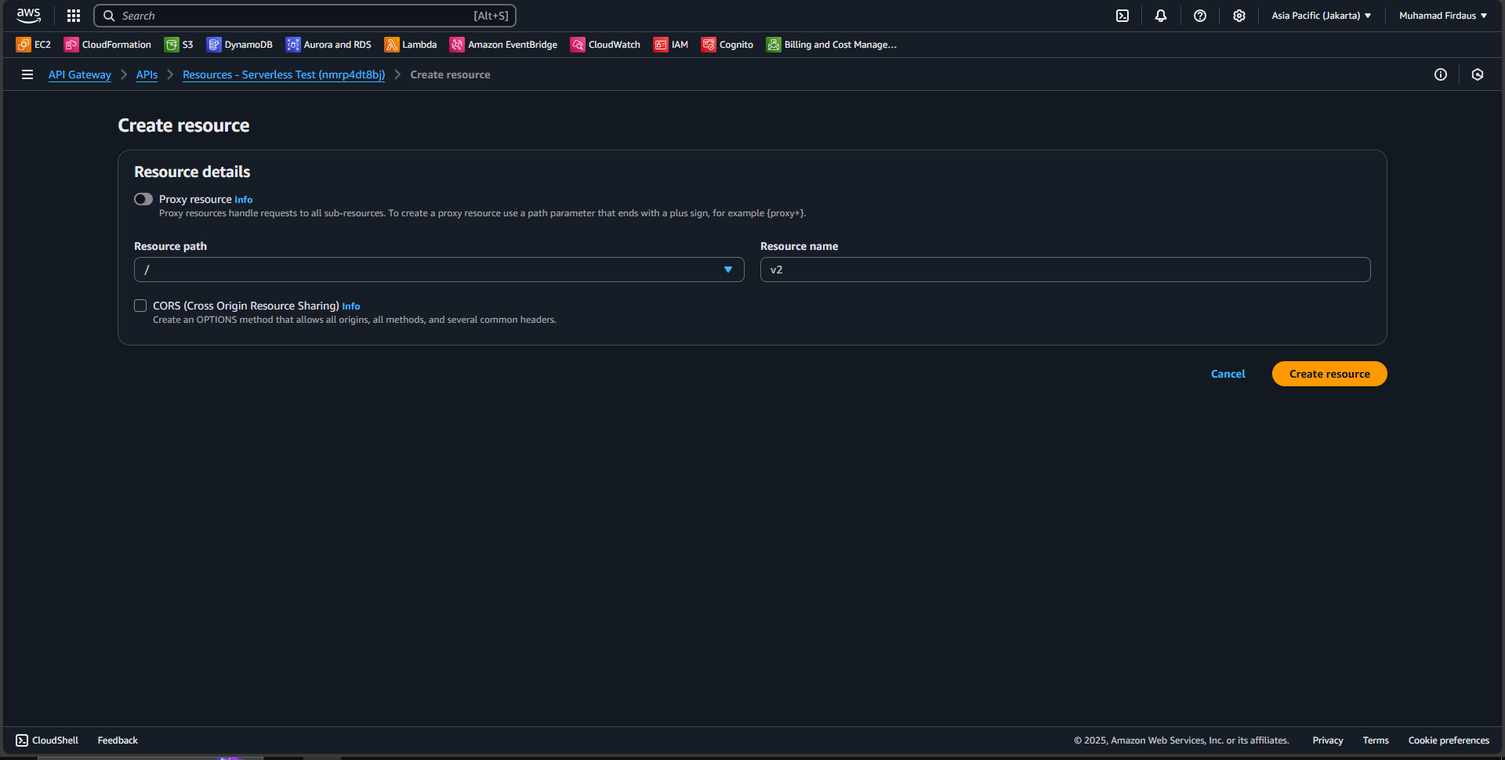

1. Click on the “/v2” to choose it as the current path and then click again on the create resource menu to create a new resource under the “v2” path.

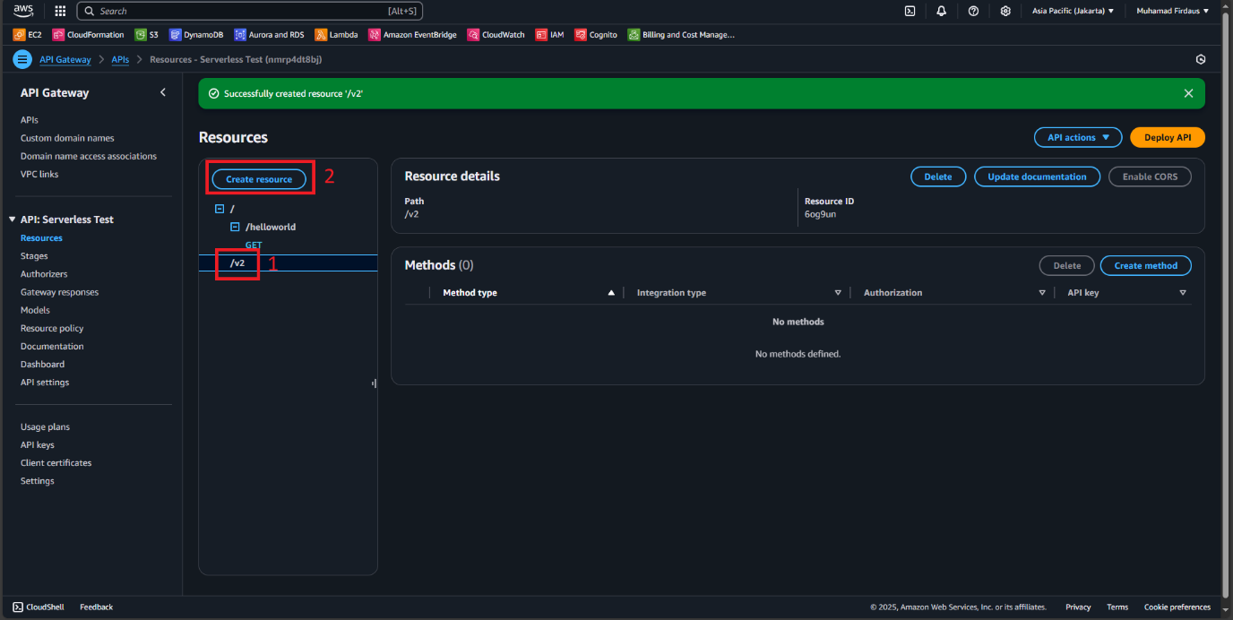

1. Make sure to check the resource path is on the “v2” and then input the name you want to be using as the resource name, I will be choosing another “helloworld”.

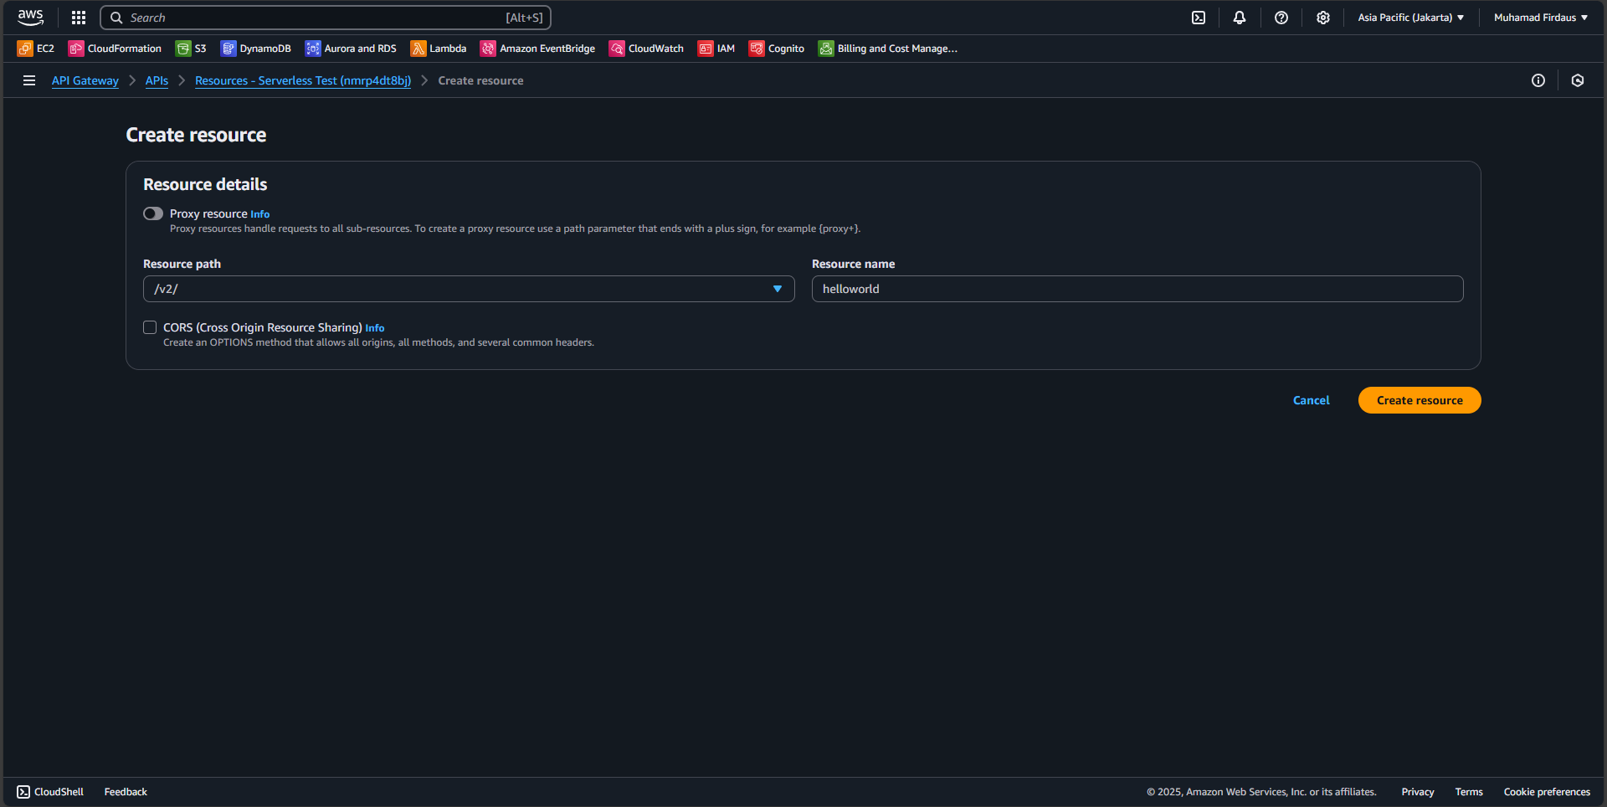

1. When the “helloworld” resource is created inside the “v2”, click on it and then choose to create a new method inside the helloworld resource.

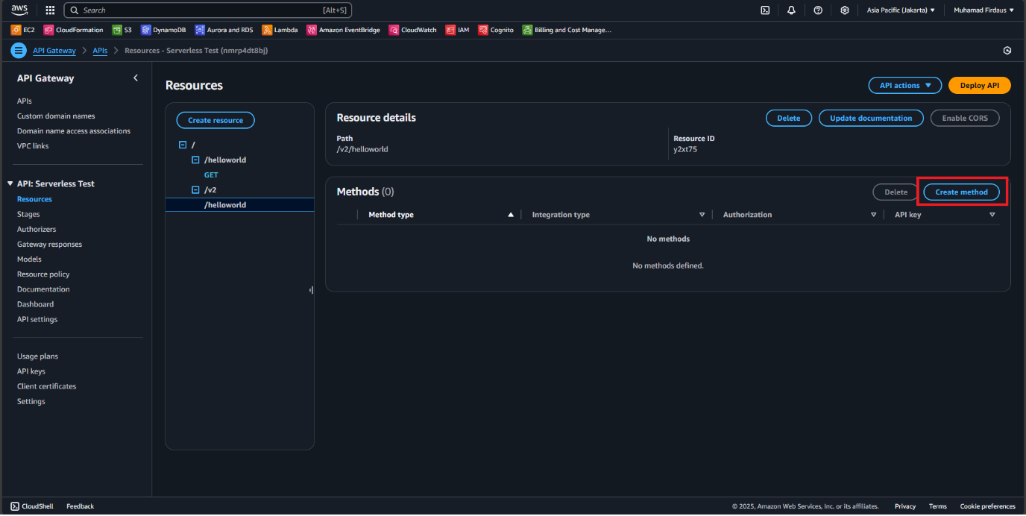

1. We’ll be using the GET method again, and this time we choose the “dausFunction2” as the lambda function. Create the method after leaving all the settings in default.

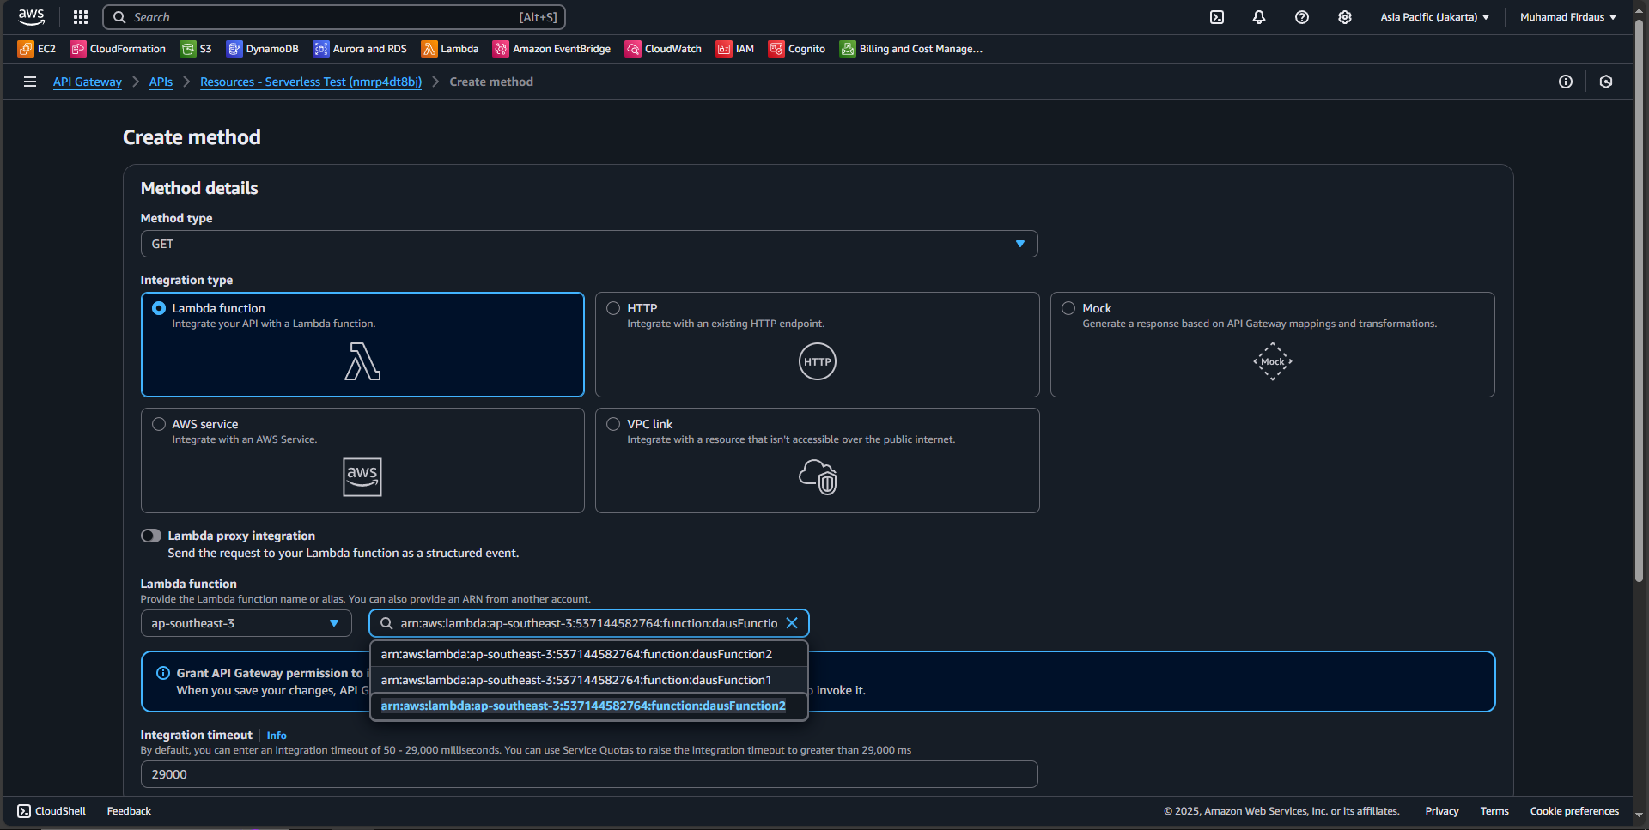

1. Click on the GET method inside the v2 helloworld, then choose to deploy a new API inside of it.

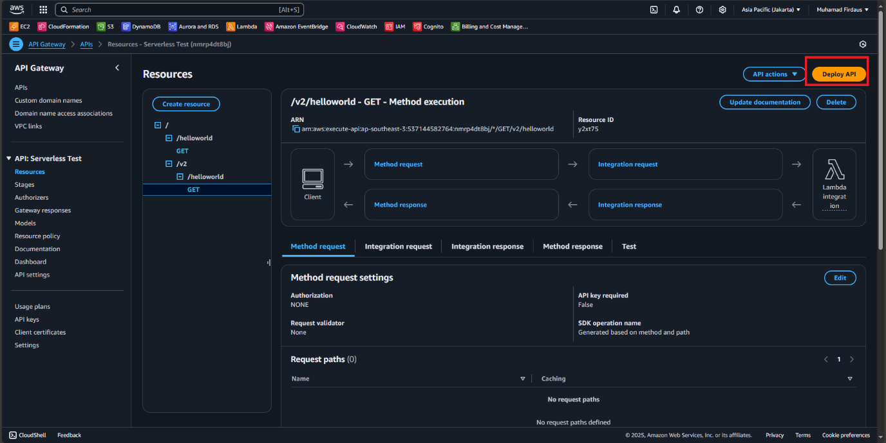

1. On the stage, we’ll be choosing “PROD” it will mention that canary is now enabled if we choose it, fill the description however you like and create the API.

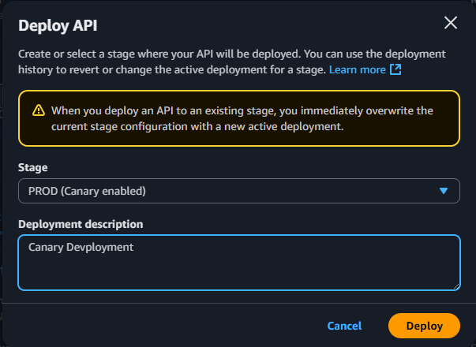

1. On the stages menu, open all the stages until you click the GET section so you can see the invoke url, copy it so we can use it to send a request to the canary gateway.

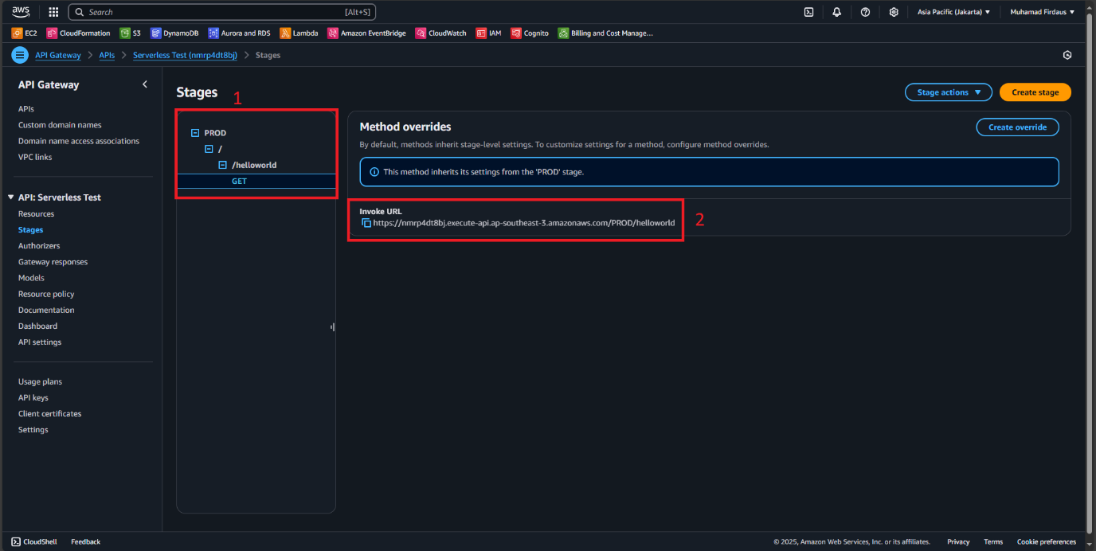

1. Open up your API testing tools, again I will be using Postman, enter a new task, choose HTTP and use the GET method, then paste the Invoke URL we copied before (don’t forget to add the /v2/ path before the helloworld since we havent configured it to be automatically invoked on the URL) then choose to sent your request. If your configuration is correct then you will see your message in the different setup than the first lambda function as seen here.

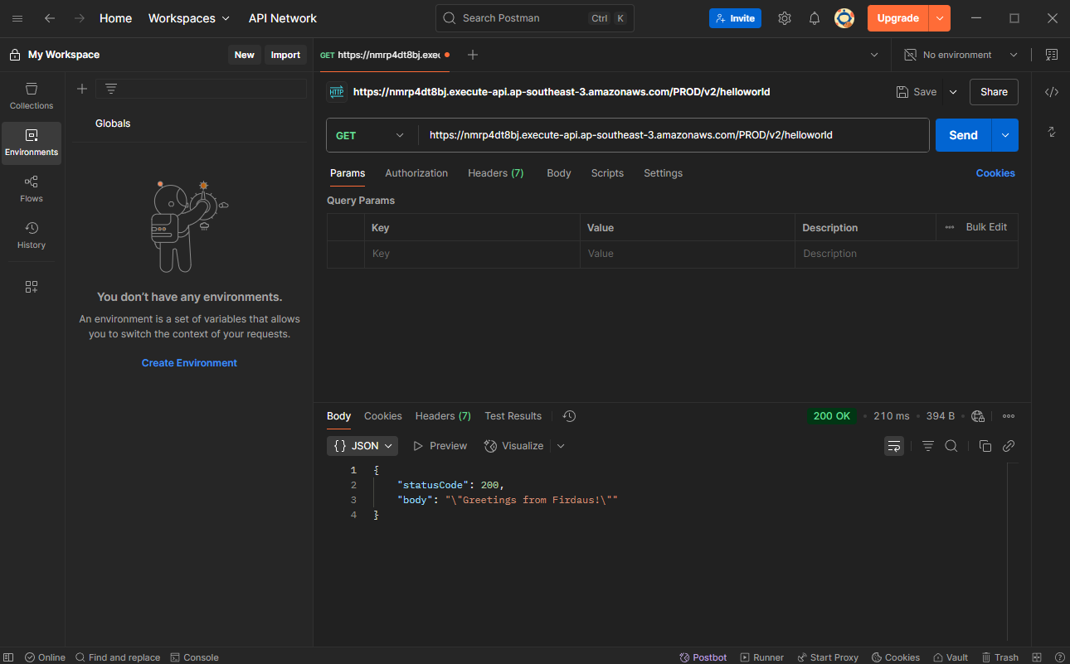

1. Return to the AWS console and click on the PROD menu, and choose on canary option.

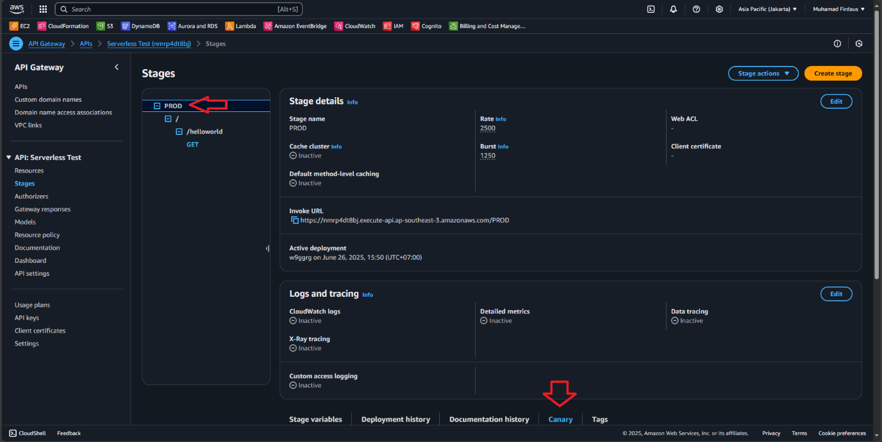

1. Now after confirming that the canary is reachable, we can promote the canary by clicking on the “Promote Canary” button inside the canary option menu.

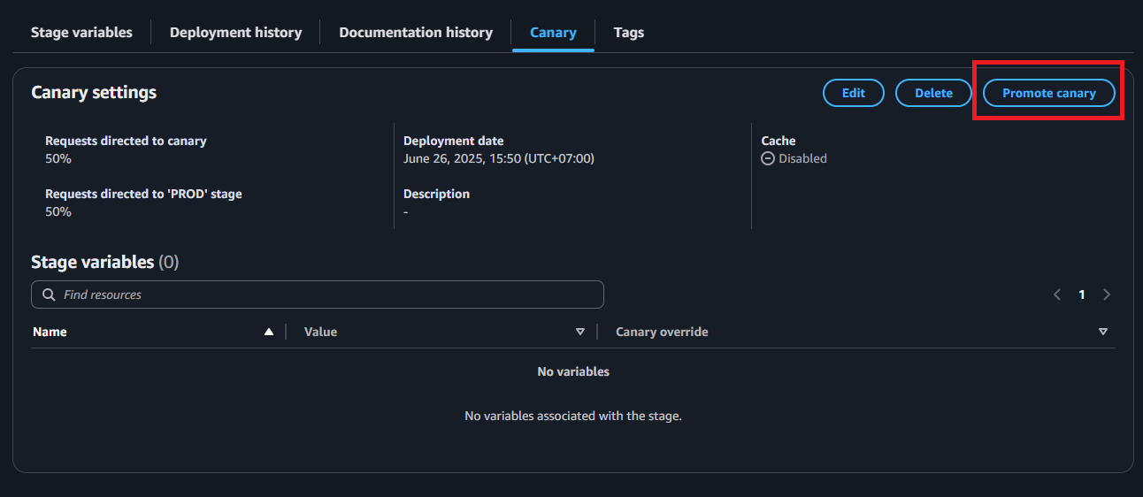

1. A new pop up will show and ask you regarding the configuration for the canary promotion, checks all the box to update the settings of the gateway and then click on “Promote canary” to promote the new developed canary.

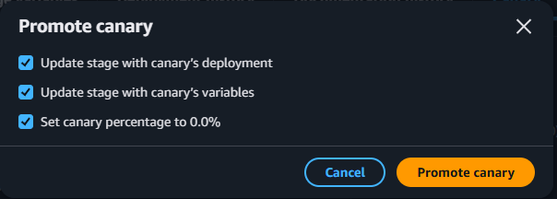

1. After a successful promotion we can see the GET method from the v2/helloworld is now live and deployed to the PROD. This means the helloworld will be changed with the v2 version of it.

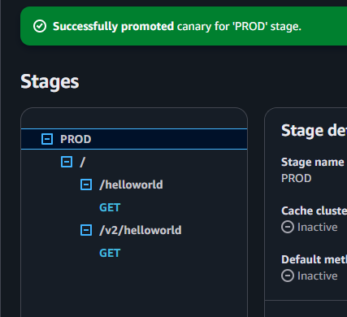

**PART 4 : CORS API Gateway**

1. A
2. A
3. A
4. A
5. A
6. A
7. A
8. A
9. A
10. A
11. A
12. A
13. A
14. A
15. A
16. A
17. A
18. A
19. a